Rocket Pesto, Fresh Tomato & Bocconcini Pizza
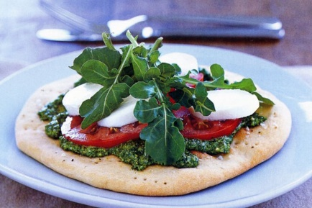
2 tablespoons olive oil
Salt & freshly ground black pepper
4 ripe tomatoes, thinly sliced crossways
1 x 210g container bocconcini, sliced
Rocket leaves, to garnish

- Cut tomatoes into slices as thin as possible.
- Slice bocconcini into thin slices.
- Wash rocket leaves. Drain and then spin in salad spinner.
- Keep rocket leaves to finish the pizza after the pizza bases have been topped and cooked.
- Prick the rolled out bases all over with a fork.
- Brush the pizza bases lightly with olive oil, and season with salt and pepper.
- Bake in oven, preheated to 220°C swapping trays halfway through cooking, for 8 minutes.
- Spread pizza bases with rocket pesto. Top with tomato and bocconcini, and garnish with rocket. Serve immediately.

