Triple Chocolate Cookie Recipe
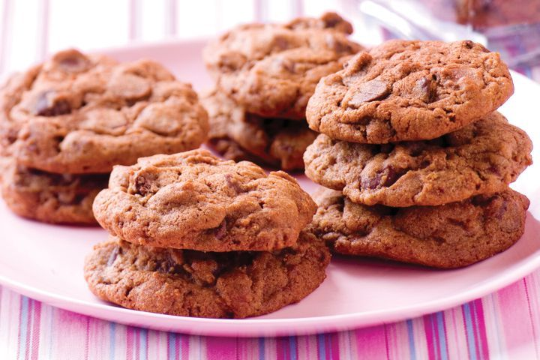
Makes 30

Ingredients:
-125g softened butter
-2 tsp vanilla essence
-1 cup firmly packed brown sugar
-1 egg
-3/4 cup plain flour
-1/2 cup self-raising flour
-2 Tbs cocoa powder
-150g dark chocolate chips
-100g white chocolate chips

Method
- Preheat oven to 180⁰C. Line two baking trays with baking paper.
- Using electric beaters, cream butter and brown sugar in a large bowl until smooth.
- Beat in egg and vanilla until well combined.
- Add flour and cocoa and mix until a soft dough forms.
- Stir through chocolate chips.
- Place tablespoons of mixture onto prepared trays, leaving 4 – 6cm between each.
- Bake for 12-15 minutes or until just firm on the surface.
- Allow to cool on tray for 5 minutes, then transfer to wire rack to cool completely. Enjoy.

