Warrigal Greens Pesto & Pasta
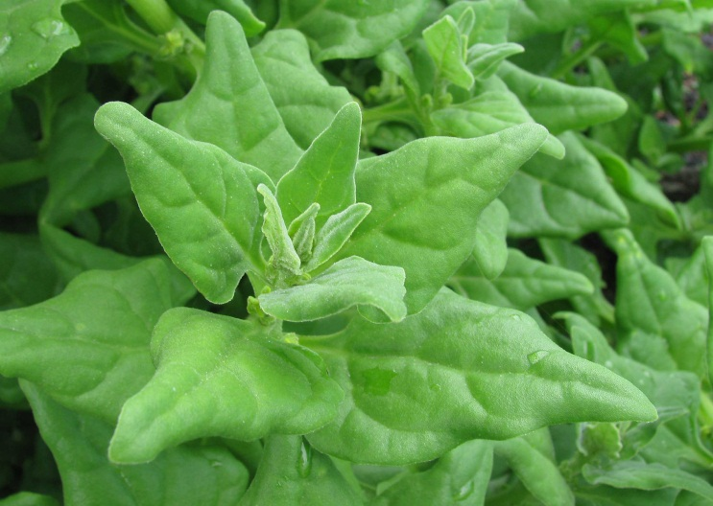
Ingredients:
2 handfuls of Warrigal Greens
1 onion, finely chopped
1/2 packet of spinach
6 cloves garlic
1 can chickpeas (drained)
2 cups olive oil
Juice of 1 lemon
200g grated parmesan cheese

Method:
- Remove warrigal green leaves from stems and wash well.
- Place in a medium pot of boiling water and simmer 3-5 minutes
- Strain and place in food processor.
- Fry finely chopped onion in a frying pan with a small amount of olive oil and then add to food processor.
- Peel garlic cloves and add to food processor.
- Add lemon juice, olive oil and chickpeas.
- Process until thick and fairly smooth. Add more oil if it is too thick.
- Stir in parmesan cheese.
- Add more lemon juice and season with salt and pepper if needed. If it isn’t smooth enough, add a little more oil or process further.
- Cook pasta to packet directions – drain and place in a mixing bowl.
- Add pesto and mix to coat pasta.
- Serve.

