[](http://www.google.com.au/url?sa=i&rct=j&q=&esrc=s&source=images&cd=&cad=rja&uact=8&ved=0ahUKEwip16WW_d3MAhXFnpQKHSByCtAQjRwIBw&url=http://www.dogoilpress.com/FDS-396756.html&psig=AFQjCNFE8WffKP1r9rIyd-iMiHYRN3waSg&ust=1463466881776588)[](http://www.google.com.au/url?sa=i&rct=j&q=&esrc=s&source=images&cd=&cad=rja&uact=8&ved=0ahUKEwiz6KbQg97MAhVoJ6YKHQK_BHAQjRwIBw&url=http://www.tarameddaugh.com/blog/2015/9/3/reading-with-your-child-start-drama-early&bvm=bv.122129774,d.dGY&psig=AFQjCNFR_pdP4IrHnH-mDJIpVx_p75UDBw&ust=1463468619554548)[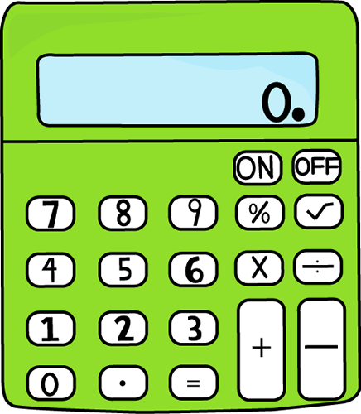](http://www.google.com.au/url?sa=i&rct=j&q=&esrc=s&source=images&cd=&cad=rja&uact=8&ved=0ahUKEwj02disg97MAhVFtJQKHR67D_EQjRwIBw&url=http://www.mycutegraphics.com/graphics/school/supplies/lime-green-calculator.html&bvm=bv.122129774,d.dGY&psig=AFQjCNEavZJHBge9dm9mbQPAIyV7FfN68w&ust=1463468548912327)[](http://www.google.com.au/url?sa=i&rct=j&q=&esrc=s&source=images&cd=&cad=rja&uact=8&ved=0ahUKEwjm25iahN7MAhWIQpQKHbSKBlgQjRwIBw&url=http://4-designer.com/2014/07/Cartoon-chef-design-vector-material/&bvm=bv.122129774,d.dGY&psig=AFQjCNFkQnJgl52Ra0R51kCpT2bMlQ-q-g&ust=1463468726726551)[](http://www.google.com.au/url?sa=i&rct=j&q=&esrc=s&source=images&cd=&cad=rja&uact=8&ved=0ahUKEwixpfWA_t3MAhUGVZQKHYjiBjQQjRwIBw&url=http://www.clipartpanda.com/categories/school-newspaper-clipart&bvm=bv.122129774,d.dGY&psig=AFQjCNHept1E2zoD0Mep01i8ptYiFz9TUA&ust=1463467040400840)

***Term 3 Week 2***

Literacy

In Reading, students are identifying elements of news articles. Elements that have been discussed are the different types of headlines and how they draw a reader in, the byline, datelines and how articles are written in third person. Students then transferred this learning focus onto their independent reading text using Kids News on their laptops.

In Writing, students have been focusing on writing using the elements of news articles. Using pictures as stimulus, students have been creating different headlines to engage the reader. This has been done using questions, numbers, quotes and statements.

Student have also been exploring their Writer’s Notebooks. Creating a chart of their holidays, creating seeds (writing ideas) and extracting elements of their seeds to incorporate into their writing have been focused on.

Maths

In Maths, students have been working on their times tables and mental computation skills through our daily quick maths session. They have learnt to subtract fractions with the same and differing denominators. Students have also been learning about place value using decimal ruler and segmenting them into tenths, hundredths and even thousandths.

Integrated

This semester is unit, ‘The Promised Land’ students, study of colonial Australia in the 1800s and the development of Australia as a nation, particularly after 1900. Students look at the founding of British colonies and the development of a colony. They learn about what life was like for different groups of people in the colonial period.

Friday Sport

In the coming weeks, students will be competing in teams in a round robin style competition. Teams will be playing a variety of games including rounders, bat tennis and Ultimate Frisbee. Students will also be taking turns officiating games, developing ladders and organising equipment required.

Swimming

Students have been undertaking swimming lessons at King Swim in Chirnside Park. We received a named swimming cap on first arrival and were eager to step foot into the warm water. Students have been refining their swimming techniques of freestyle, backstroke, breaststroke and butterfly. Flippers, diving toys and kickboards have been utilised to improve the different kicks required for certain strokes.

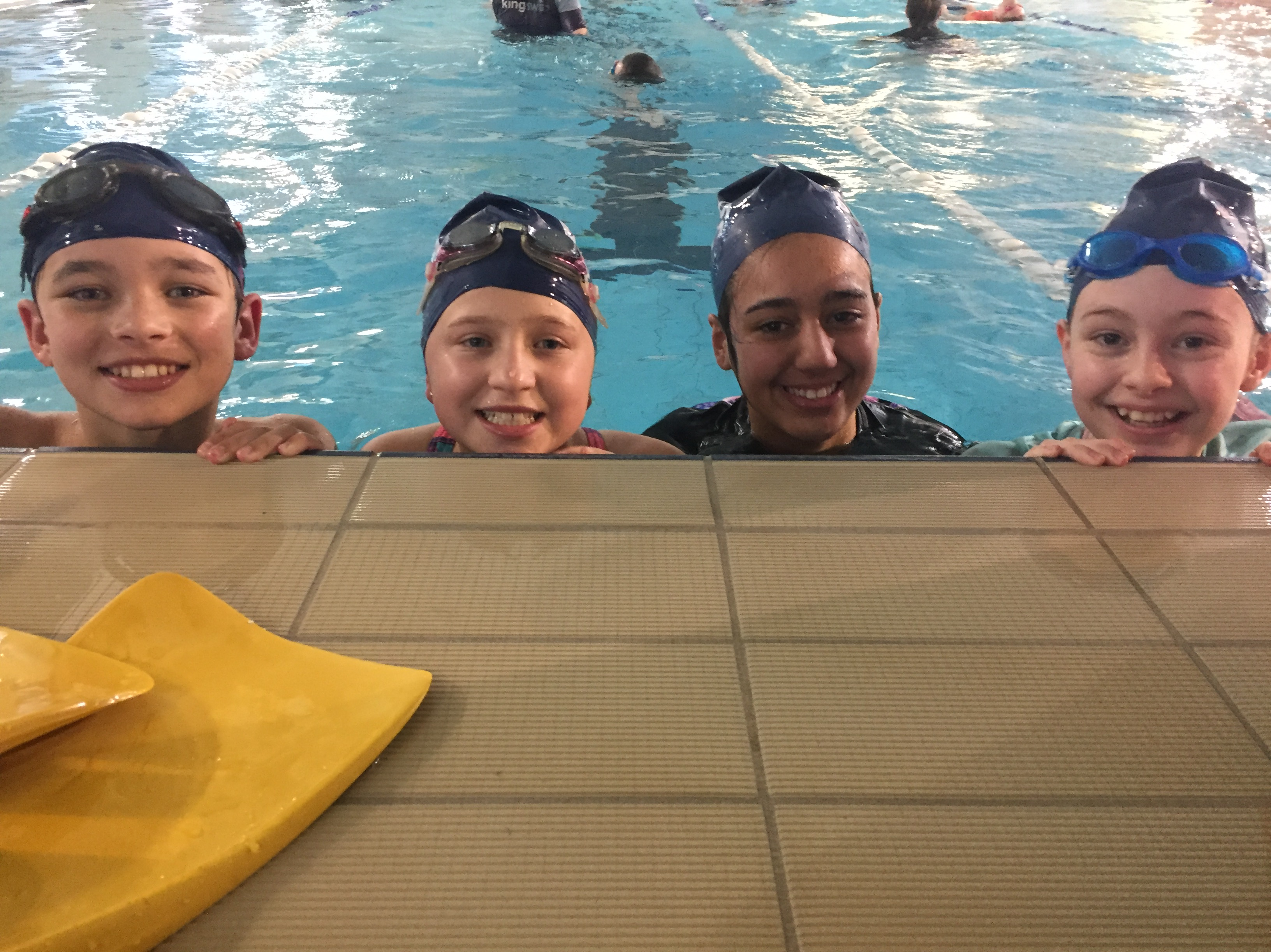 5/6’s have had a fantastic time and we were even commended for tour manners and behaviour from Centre Management. ***Congratulations 5/6 students on representing Dorset PS with such pride.***

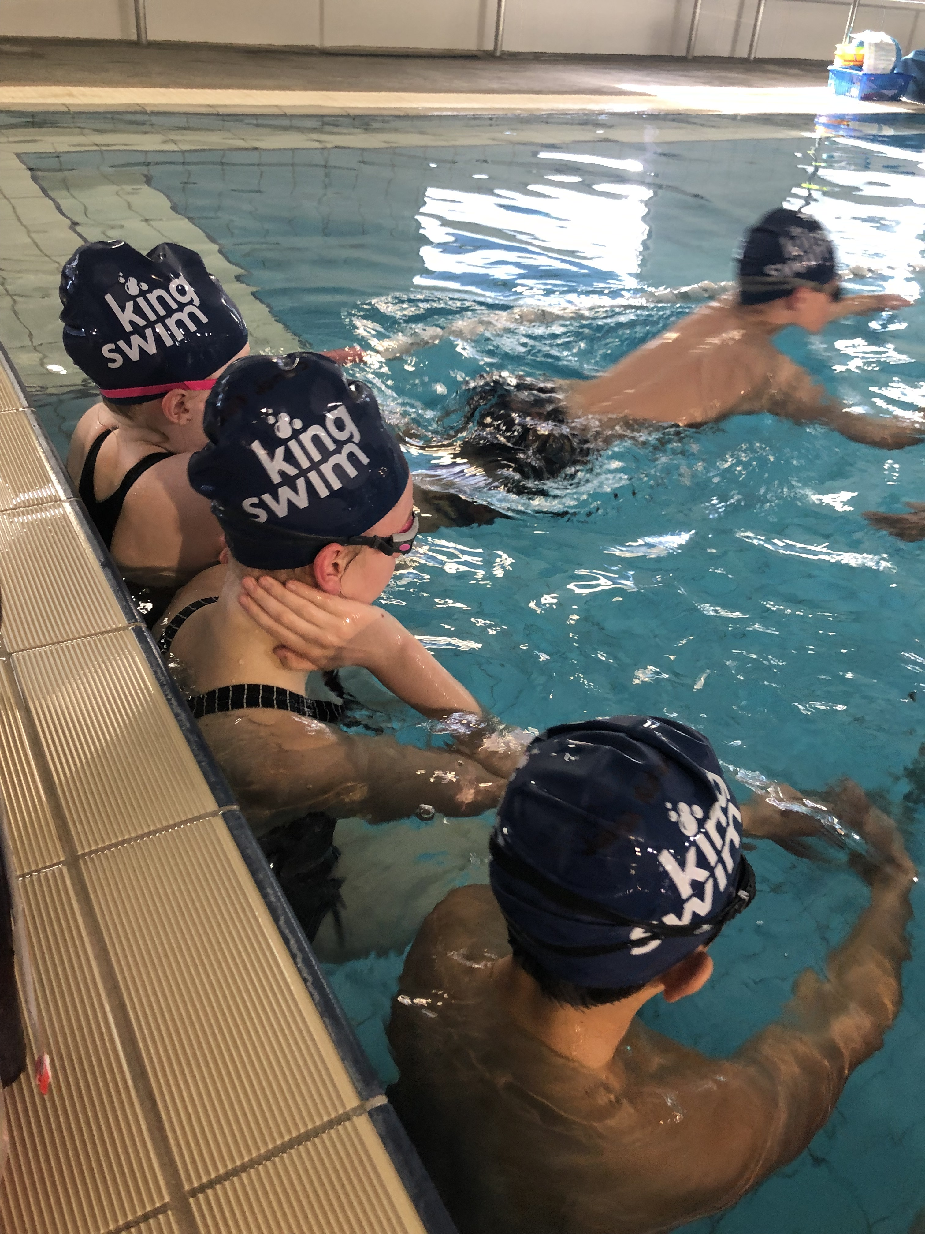

Coming Up:

**Girls AFL Gala Day- 1/8**

**Production Evening Workshop for Main Cast- 9/8**

**Book Parade 21/8**

**Book Fair 21/8 to 28/8**

**District Athletics- TBD early September.**

5/6s

NEWS

**FROM**

**THE**