Creamy pumpkin pasta
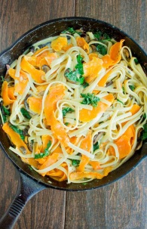
Ingredients:
500g spiral pasta | 120mls olive oil
4 garlic cloves, crushed | 4 sprigs sage leaves
500g peeled and seeded pumpkin, coarsely grated | 600ml cream
100g parmesan/grana padano, grated | 100g kale leaves
200g warrigal green leaves | 200g Silverbeet leaves (use more kale if silverbeet not available)
½ cup parsley leaves
Method
- Peel and de-seed pumpkin. Weigh amount of pumpkin needed and cut into smaller pieces to make grating easier. Grate pumpkin.
- Peel and crush garlic. Wash sage and remove leaves from stems.
- Cook pasta in a large saucepan of boiling salted water, until tender. Drain.
- Heat oil in a large, deep frying pan over medium heat. Add garlic and sage (be careful not to get too much colour on the garlic or it will taste bitter.
- Cook, stirring for 1-2 minutes or until fragrant.
- Add grated pumpkin. Cook, stirring occasionally, until the pumpkin is tender.
- Wash kale and silverbeet, remove stalks and finely shred the leaves.
- Wash warrigal greens. Remove stalks. Cook warrigal greens in boiling water for 5 minutes, then drain and cool under cold running water. Roughly chop warrigal greens.
- Add cream. Cook for 5 minutes or until heated through.
- Add Warrigal Greens, Silverbeet, Kale and pasta to pumpkin mixture.
- Wash parsley, remove stalks and finely chop parsley. Grate Parmesan/Grana Padano.
- Season with salt and pepper. Add chopped parsley. Gently toss pasta to combine.
- Add parmesan cheese and mix through pasta. Check seasoning and add more salt and pepper if needed. Serve.

