[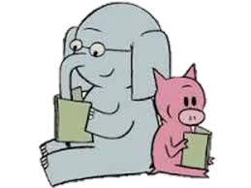](http://www.google.com.au/url?sa=i&rct=j&q=&esrc=s&source=images&cd=&cad=rja&uact=8&ved=0ahUKEwiz6KbQg97MAhVoJ6YKHQK_BHAQjRwIBw&url=http://www.tarameddaugh.com/blog/2015/9/3/reading-with-your-child-start-drama-early&bvm=bv.122129774,d.dGY&psig=AFQjCNFR_pdP4IrHnH-mDJIpVx_p75UDBw&ust=1463468619554548)[](http://www.google.com.au/url?sa=i&rct=j&q=&esrc=s&source=images&cd=&cad=rja&uact=8&ved=0ahUKEwip16WW_d3MAhXFnpQKHSByCtAQjRwIBw&url=http://www.dogoilpress.com/FDS-396756.html&psig=AFQjCNFE8WffKP1r9rIyd-iMiHYRN3waSg&ust=1463466881776588)[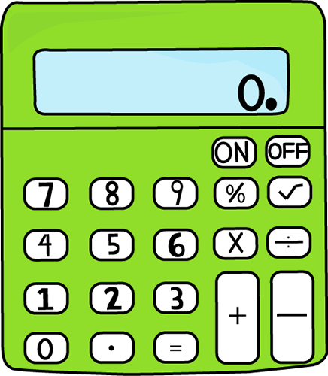](http://www.google.com.au/url?sa=i&rct=j&q=&esrc=s&source=images&cd=&cad=rja&uact=8&ved=0ahUKEwj02disg97MAhVFtJQKHR67D_EQjRwIBw&url=http://www.mycutegraphics.com/graphics/school/supplies/lime-green-calculator.html&bvm=bv.122129774,d.dGY&psig=AFQjCNEavZJHBge9dm9mbQPAIyV7FfN68w&ust=1463468548912327)[](http://www.google.com.au/url?sa=i&rct=j&q=&esrc=s&source=images&cd=&cad=rja&uact=8&ved=0ahUKEwjm25iahN7MAhWIQpQKHbSKBlgQjRwIBw&url=http://4-designer.com/2014/07/Cartoon-chef-design-vector-material/&bvm=bv.122129774,d.dGY&psig=AFQjCNFkQnJgl52Ra0R51kCpT2bMlQ-q-g&ust=1463468726726551)[](http://www.google.com.au/url?sa=i&rct=j&q=&esrc=s&source=images&cd=&cad=rja&uact=8&ved=0ahUKEwixpfWA_t3MAhUGVZQKHYjiBjQQjRwIBw&url=http://www.clipartpanda.com/categories/school-newspaper-clipart&bvm=bv.122129774,d.dGY&psig=AFQjCNHept1E2zoD0Mep01i8ptYiFz9TUA&ust=1463467040400840)

Literacy

In Reading, students have been identifying the different styles and structures authors use to engage their audience. Strategies include; show don’t tell, where the visual is provided but the meaning implied, use of different sentence structures and language used.

Our spelling sound for this week has been ‘Ducks Dive Down- d, d, d’. Students have been learning if a word ends with ‘d’ or ‘de’, we usually change this sound to ‘a’ before adding ‘ion’, an example of this divide turns into division.

During Writing time, students continued with the genre of poetry by constructing poems using the structure ABAB. Students ensured their ABAB poem following the “end rhymes”. Each new sound at the end of a line is given a letter, started with “A,” then “B,” and so on. These and a selection of our colour poems can be seen on display on our Writing Wall located near the office.

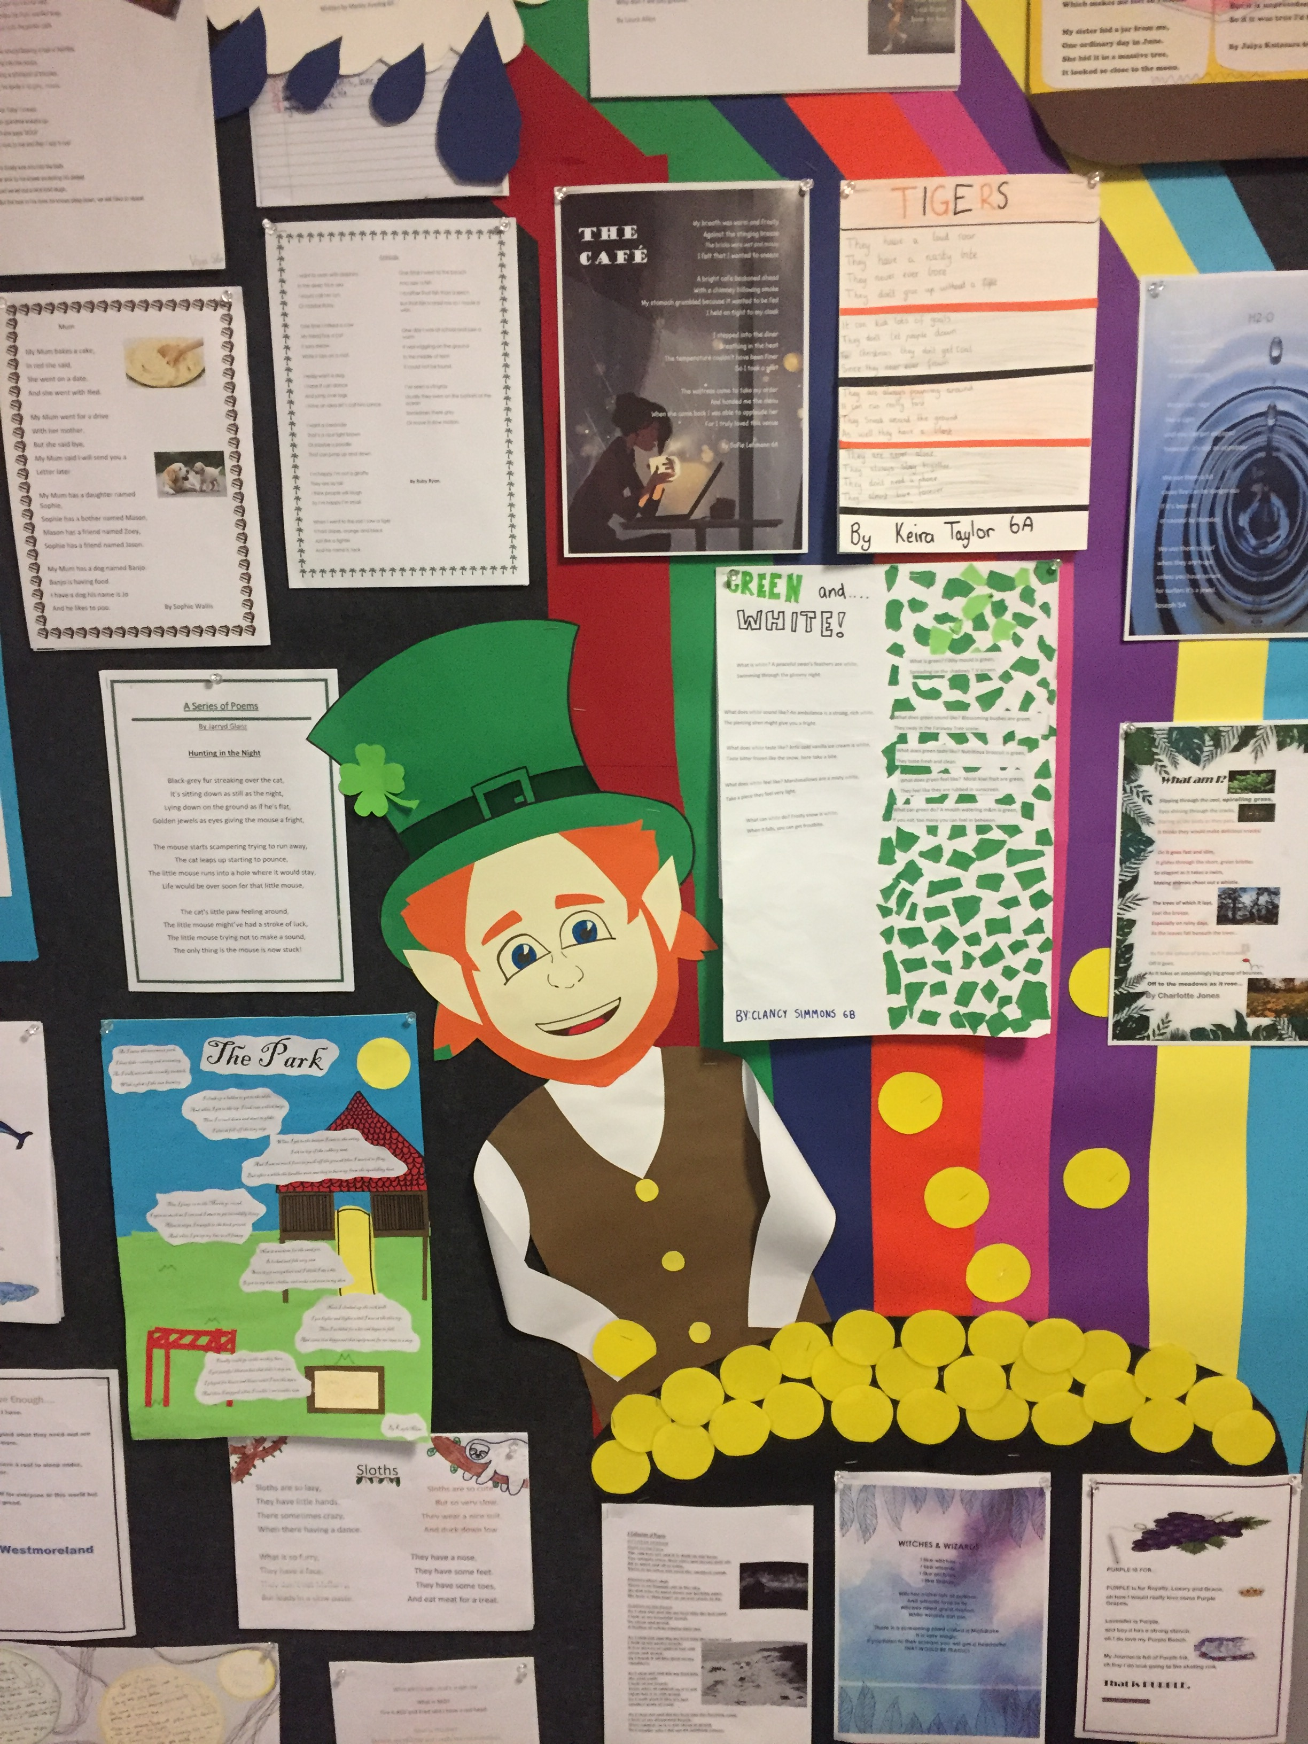

In our Writer’s Notebooks, students have been exploring what makes them happy, connecting this to their feelings and things that they know. These continue to grow other ‘seeds’ (writing ideas) for future and current written pieces.

Maths

In Mathematics, we have been practising addition and subtraction through the use of formal algorithms. Students have been selecting equations at their level to complete. We are then using that knowledge to help complete a variety of problem solving tasks.

Specialist

In Science, students are learning the parts of flowers and how to list them on diagram.

In Performing Arts, students have been learning choreography to a set dance of a decade in time that students will perform.

In P.E with Miss Carter, students have been focusing on their athletic performance and measuring their long and triple jump distances.

In Digital Technology with Mr Beggs, students tested their knowledge of input and output peripheral devices through Kahootz surveying.

SAKG sessions with Gregg have produced black bean and honey hokkien noodles and stone fruit crumble. In the Garden with Ally, most students have been weeding the garden and learnt to pot seed correctly.

Notes to Return:

Acceptable Use Agreement

Healthmont College Sports Day permission form (Select Grade 6 students only)

Coming Up:

**Labour Day**- 9/3

**Vintage Market-** 13/3

**School Photos** – 17/3

**Heathmont College Sports Day-** 26/3

Cyber Safety

Social media platforms have become an integral part of online lives. Social networks are great way to stay connected with others, but you should be wary about how much personal information you post. As a 5/6 team we have discussed the risk and responsibilities of communicating online.

5/6s

NEWS

**FROM**

**THE**